Overview - Word Embeddings

[Previous](https://olympus.mygreatlearning.com/courses/111352/modules/items/5520598?pb_id=17388)

[Next](https://olympus.mygreatlearning.com/courses/111352/modules/items/5520601?pb_id=17388)

#### [NLP_Upt-Week-2-Journey-Map.png](https://olympus.mygreatlearning.com/courses/111352/modules/items/5520601?pb_id=17388)

#### **QUICK RECAP**

In the previous week, we learned about the evolution and applications of NLP, and how to clean and vectorize text data for analysis. Let us quickly recap what we have covered so far.

* Overview of NLP
* History of NLP
* Different Applications of NLP
* Text Cleaning
* Text Vectorization
* Sentiment analysis

#### **COURSE OVERVIEW**

**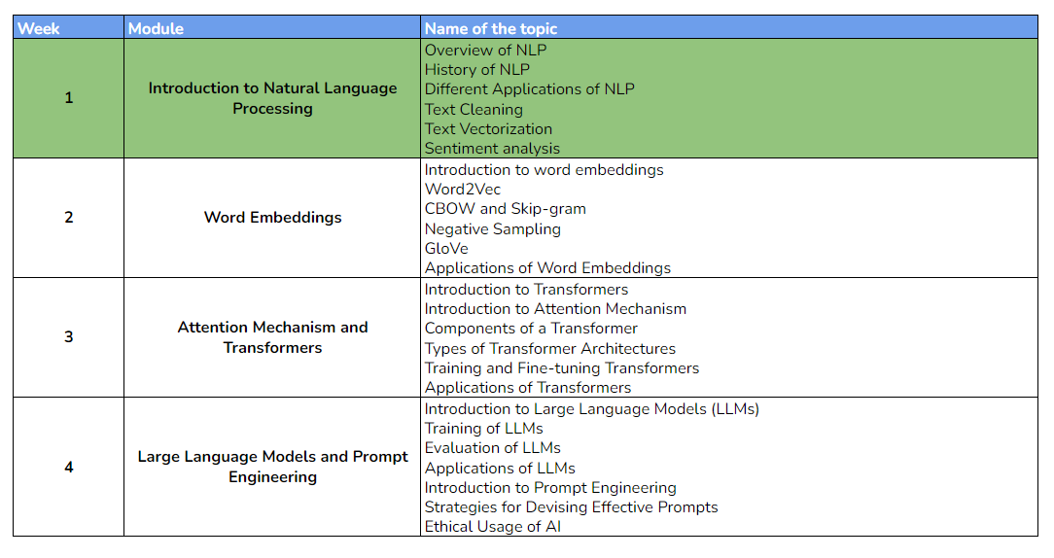**

#### **WEEK 2 OVERVIEW**

This week, we will be learning about what are word embeddings and types of word embeddings. The following topics will be covered in this module:

* Introduction to word embeddings
* Word2Vec
* CBOW and Skip-gram
* Negative Sampling
* GloVe
* Applications of Word Embeddings

#### **LEARNING INSTRUMENTS**

| **Week** | **Module** | **No. of Videos** | **Total Duration** | **No. of Test Your Understanding Quizzes** | **No. of Graded Quizzes** | **No. of Practice Assignments** |
| --- | --- | --- | --- | --- | --- | --- |
| 1 | Vectorization and Word Embeddings | 17 | ~2.5 hours | 17 | 1 | 1 |

#### **Note:** It is recommended to spend at least 1 hour/day along with practicing datasets and quizzes.

**Power Ahead!**